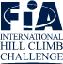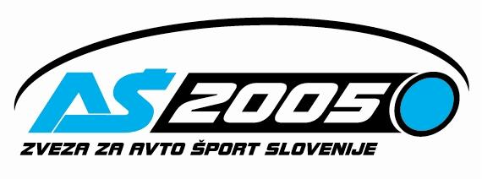

FIA MEDNARODNA AVTOMOBILSKA GORSKA HITROSTNA DIRKA ROGLA 2006
FIA Hill Climb Challenge / Odprto državno prvenstvo Republike Slovenije / Avstrijsko državno prvenstvo

Rogla, od petka 23.junija do nedelje 25. junija 2006

GHD UNIOR ROGLA 2006

TEHNIČNI PREGLED / TECHNISCHE ABNAHME / SCRUTINEERING

Ura/Time Skupina/Gruppe Štartna št./Start N⁰.

13:10 HISTORIC 315, 316, 317, 318, 319, 320,
13:30 HISTORIC 321, 322, 323, 324, 325,
-----------------------------------------------------------------------------------------------
13:45 N 142, 110, 112, 102, 105,
14:00 N 108, 109, 111, 113, 114,
14:15 N 115, 116, 117, 6, 26, 48, 49,
-----------------------------------------------------------------------------------------------
14:40 A 131, 133, 134, 136, 137, 138,
15:00 A 141, 146, 149, 150, 152,
15:15 A 154, 157, 159, 162, 163,
15:30 A 164, 165, 166, 11, 71,
15:45 A 72, 73, 74, 75, 52,
16:00 A 53, 54, 56, 57, 58,
16:15 A 59, 60, 61, 62, 8,
15:45 A 46, 47, 25,
-----------------------------------------------------------------------------------------------
16:00 E1 43, 44, 45, 156, 96,
16:15 E1 41, 42, 50, 98, 4,
16:30 E1 7, 14, 35, 36, 37,
16:45 E1 38, 39, 40, 51, 99,
17:15 E1 16, 3, 10, 12, 22,
17:30 E1 23, 24, 28, 29, 30,
17:45 E1 + ST 31, 32, 33, 34, 2,
---------------------------------------------------------------------------------------------------
18:00 CN/C3 207, 208, 209, 226, 210,211,
---------------------------------------------------------------------------------------------------
18:20 E2/D 225, 205, 206, 201, 202, 215, 203, 204,
---------------------------------------------------------------------------------------------------
18:40 Seicento 603, 605, 606, 607, 610, 611, 618
---------------------------------------------------------------------------------------------------

Direktor dirke:
KNEZ Andrej

