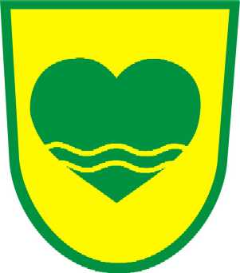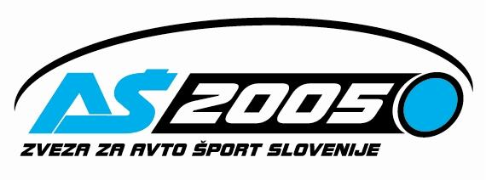

INTERNATIONAL FIA HILL CLIMB UNIOR ROGLA 2007
FIA Hill Climb Challenge / Open National Championship of Slovenia / Austrian National Championship

Rogla, Friday, 22 June through to Sunday 24 June 2007

VLOGA ZA AKREDITACIJO / ACCREDITATIONS FORM / AKKREDITIERUNG FORMULAR

NAZIV MEDIJA | MEDIA NAME | MEDIUM NAME DATUM/ DATE

NASLOV | ADDRESS | ADRESSE DRŽAVA | COUNTRY | STAAT

VRSTA MEDIJA | TYPE OF MEDIA |

X | X | X | X | X | X
Dnevni časopis  Daily newspaper  Tageszeitung | Revija  Magazine  Zeitschrifft | TV | Radio | Internet | Video

SPLETNI NASLOV | WEBSITE | INTERNET ADRESSE
http://

IME NOVINARJA | MEDIA REPRESENTATIVE | JOURNALIST NAME  TELEFON | TELEPHONE NUMBER | TELEFON NUMMER  EMAIL | VLOGA NOVINARJA |  MEDIA REPRESENTATIVE ROLE | MEDIUM VERTRETER ROLLE  X  novinar/ journalist/Journalist  X  X  Foto / Video  pomočnik/assistant/Assistent

Nameravam obiskati novinarsko konferenco /I Intend to participate on Press Conference/
YES / NO

YES / NO
YES / NO

Zreče Četrtek/Thursday 14. Junij 12.00
Ljubljana Torek/ Tuesday 19. Junij 12.00
Rogla Nedelja / Sunday 15 min po dirki/ after the End of the Race

Opombe/Various/Verschiedenes

Vlogo je potrebno poslati na elektronski naslov: press@vracing.info ali fax +386 3 897 04 81
Form has to be send to Email or Facsimile
Diese Formular mussen Sie an Email oder Fax senden

